# Enrollment REACH local server

1. Access the local Reach server (for example for PCAC: <http://10.172.100.2:7001/>)
2. Enter the credentials (id = sample / psw= reachip45*)
3. Go in “Management” > TV Configuration and Export the most recent configuration:

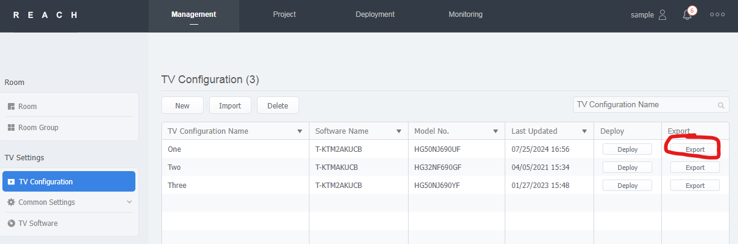

1. Extract the compressed .zip file you’ve just downloaded.
2. Put this extracted file on a USB key
3. Connect the USB key on the TV you want to enroll (the TV must be turned off)
4. Make sure the TV is connected to Internet, turn on the TV and access the advanced configuration: « Mute – 1 – 1 – 9 – Entrar » with the remote of the TV
5. Go in Room Number > Put the room number of this TV
6. Come back to the menu > Cloning > Clone from USB to TV
7. The TVs enrolled will then appear in Management > Room:

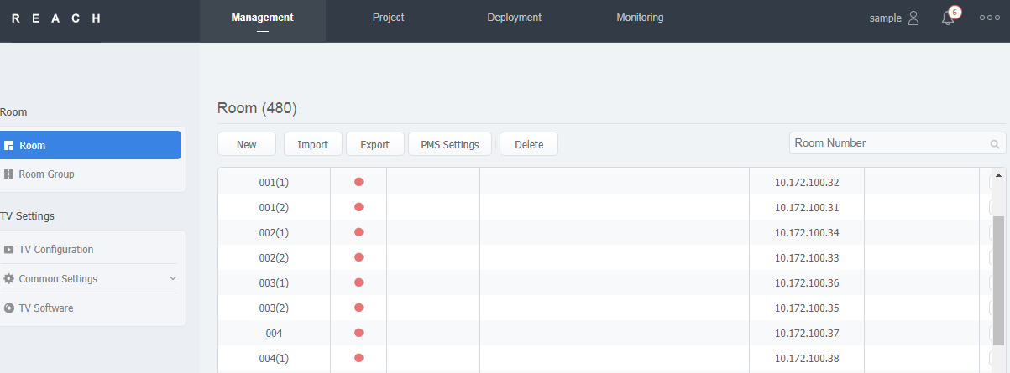

To deploy the TV Configuration on the TVs you can then go to Deployment > TV Information > Add:

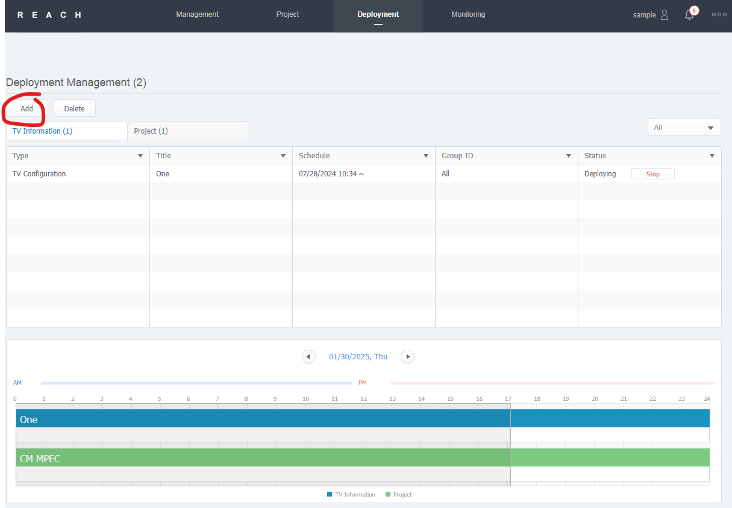

Select “TV configuration” > Title = the TV configuration you have set > Group ID = All > Deploy:

